**Car Dealership Inventory Tracker**

**1. Introduction**

**Project Name:** Car Dealership Inventory Tracker

**Objective:** A GUI-based inventory management system using Python and Tkinter, allowing car dealerships to manage their stock effectively.

**Key Features:**

* + Add, remove, and search for cars
  + Mark cars as sold
  + Store data in a CSV file
  + Simple and interactive UI

**2. System Architecture**

**Architecture Type:** Monolithic, standalone desktop application

**Technology Stack**

* + **Frontend:** Tkinter (Python GUI)
  + **Backend:** Python (OOP principles)
  + **Storage:** CSV file (Simulating a database)

**Data Flow**

* + User interacts with UI (e.g., adds/removes a car).
  + The request is processed by the Inventory class.
  + Data is stored/retrieved from inventory.csv.
  + The UI is updated accordingly.

**3. Component Design**

* **Classes & Modules**
  + **Car Class** → Represents an individual car with attributes (make, model, year, price, status).
  + **Inventory Class** → Manages car records, handles CRUD operations, and interacts with CSV storage.
  + **InventoryApp Class** → UI implementation using Tkinter.

**4. Data Storage & Schema**

**File:** inventory.csv  
**Columns:** Make, Model, Year, Price, Status

| **Make** | **Model** | **Year** | **Price** | **Status** |
| --- | --- | --- | --- | --- |
| Toyota | Corolla | 2020 | 18000 | Available |
| BMW | X5 | 2021 | 45000 | Sold |

**5. Test Cases**

| **Test Case** | **Input** | **Expected Output** | **Status** |
| --- | --- | --- | --- |
| **Add Car** | "Toyota", "Camry", "2022", "20000" | Car is added to the table & CSV | ✅ |
| **Remove Car** | Select "Corolla" & Click "Remove" | Car is removed from UI & CSV | ✅ |
| **Mark as Sold** | Select "BMW X5" & Click "Sold" | Status updates to "Sold" | ✅ |
| **Search by Make** | Enter "Toyota" & Click "Search" | Only Toyota cars are displayed | ✅ |
| **Invalid Input** | Add car with missing fields | Error message is displayed | ✅ |

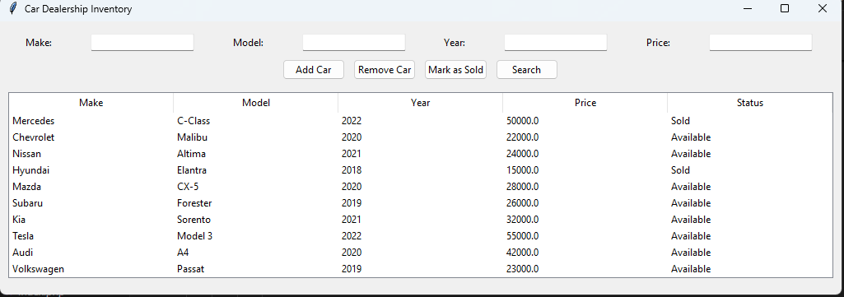

**6. Deployment & Usage**

* Install Python & required packages (tkinter, csv)
* Run python carinventory.py